DEPARTMENT OF PANCHAKARMA
The backbone of Ayurveda- Panchakarma deals with the special kind of Purificatory methods like Vamana, Virechana, Basti, Nasya and Raktamokshana. These methods not only give purification and find many solutions to unsolved problems in health.These procedures check abnormal status of Doshas due to seasonal changes as well as faulty life style, brings them back to the core status of dosha in customisedway,hence applicable for preventive, promotive& curative aspects.

Vamana – This therapeutic emesis is employed to expel toxins orally and cleanse the body.
Virechana (Therapeutic Purgation) – Evacuating the accumulated toxins through anal route is Virechana.
Basti (Trans rectal administration of drug) – The remedy to many chronic, idiopathic and degenerative diseases through the unique method of administering the medicine through rectal route
Nasya (Medicated nasal instillation) – A simpler yet an effective form of treatment that corrects the problems related to head and neck by methodical instillation of medicines through nasal route that is considered as gateway to the brain.
Raktamokshana(Bloodletting therapy)- An instant answer of remedy to reduce the intensity of pain which also purifies the blood.
The dose and the medicine/type of therapy is selected according to the disease condition.
Vision:
“Panchakarma for all classes of society”

Mission
- To provide excellent quality in Panchakarma health service
- To impart research in Panchakarma for better understanding of Science of Ayurveda
- To provide expertise to the scholars into super speciality idea
- Achieving academic and clinical excellence through motivating scientific thinking.
Specialities of Department:
- Extensive library with numerous books related to subject of Panchakarma.
- Innovation and Upgrading the department by the inculcating the students & staff to practice classical techniques with integrative teaching keeping in pace with scientific research

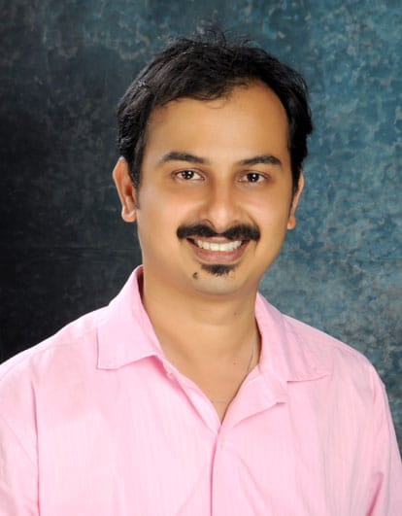 | Name: Dr. Gautam Shetty  Designation : Professor & HOD  Qualification: BAMS, MD (Panchakarma)  DOB : 24/11/1979  DOJ: 16/04/2019  Experience : 14yrs 8months  Reg no: K.A.U.P Board 16074  Teacher code:AYPK00256
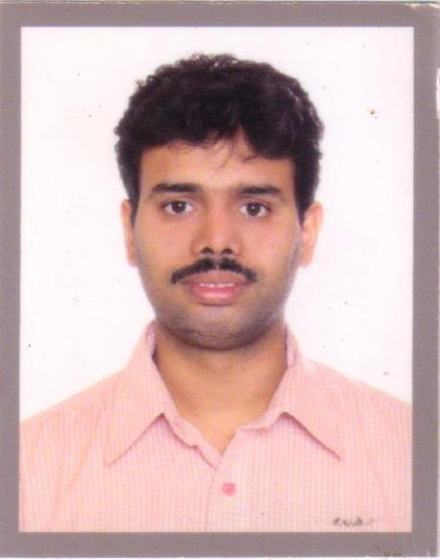 | Name: Dr.MohammedSadique  Designation: Professor  Qualification: BAMS, MD(Panchakarma)  DOB : 27/01/1983  DOJ: 11/12/2011  Experience : 11 Years  Reg no: K.A.U.P Board 21124  Teacher code: AYPK00415
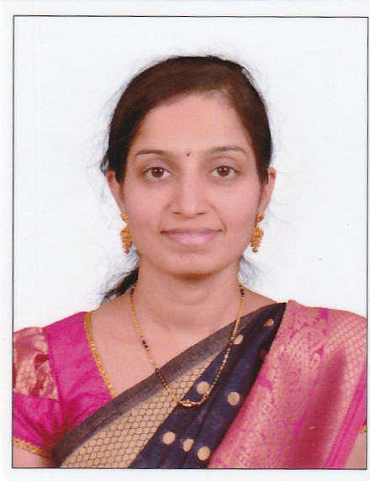 | Name: Dr.Rajeshwari T.  Designation : Associate Professor  Qualification: BAMS, MD (Panchakarma)  Additional Qualification: D.Acu  DOB : 05/05/1991  DOJ: 02/05/2019  Experience : 5yrs  Reg no: K.A.U.P Board 31039  Teacher code:AYPK00599
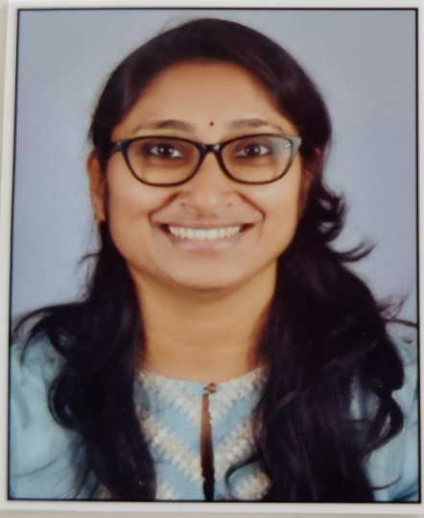 | Name: Dr.RakshaPai  Designation: Assistant Professor  Qualification: BAMS, MD (Ayu)  DOB : 27/01/1992  DOJ: 01/02/2022  Experience : 1 year,1month  Reg no: K.A.U.P Board Karnataka 33382  Teacher code: AYPK00899
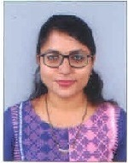 | Name: Dr.Veena Kumari  Designation: Assistant Professor  Qualification: BAMS, MD (Ayu)  DOB : 09/07/1991  DOJ: 17/03/2023  Experience : 33376  Reg no: K.A.U.P Board Karnataka  Teacher code: AYPK01246

