DEPARTMENT OF SWASTHAVRITTA
Introduction:
Swasthavritta is the branch of Ayurvedic system of medicine.Swasthavritta always trails as a pioneering science and plays an important role in preserving as well as promoting the health and prevents the onset of diseases. Swasthavritta's key formula is transforming a human being into his suitable life and life style through holistic approach of Ahara (diet), Vihara (regimen),Sadvritta (code of conduct) and Yoga. Moderation and customization of lifestyle for different groups is the key factor.
The department is well equipped with library enriched with preventive and community medicine textbooks,museum with specimens for demonstration,models, various flex charts of Asana, Pranayama, principles and practices of health. We have an exclusive space for Yoga training and yoga regular practice. We take practical yoga and naturopathy classes for the UG students as far as UG syllabus as concerned.
Our Dept constantly tries best to serve the society through the Swasthyarakshana OPD at KAMC Hospital.We avail the privilege of clinically oriented yoga sessions for the patients at the hospital. Other objectives are utilizing the principles of diets described in the classics and logically prescribing to the patients. Practical approaches towards Yoga, PathyaAhara (Therapeutic Diet), lifestyle interventions for Non communicable disease like diabetes, hypertension etc., and Degenerative diseases are also our missions.
Vision:
Promotion and propagation of positive health to the common man.
Mission:
Reaching the common man and different groups in the society with the principles and practices of Ayurveda, yoga and naturopathy and benefitting them with personal and social health.
Specialties of Department:
- Well qualified faculties with intense knowledge.
- Department manages lifestyle disorders, non-communicable disorders, Degenerative disorders, cosmetic issues at Swathyarakshana OPD.
- Well-equipped OPD with Yoga hall for demonstration.
- Provides diet prescriptions to the patients and healthy individuals.
- MUSEUM: Department is having its own well equipped museum, with display of different models and specimens, charts with descriptions of the composition and uses of all fruits, vegetables, cereals etc.,

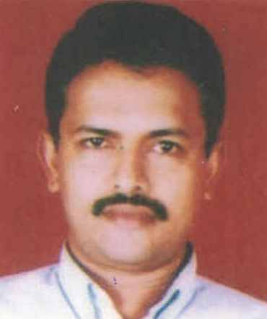 | Name: Dr.RaghavendraRao S.  Designation : Professor & HOD  Qualification: BAMS, MD (Ayu) Ph.D  Additional Qualification: M.A. Sanskrit  DOB : 05/07/1968  DOJ: 28/06/2004  Experience : 17 Years  Reg no: K.A.U.P Board 10759  Teacher code: AYSV00063
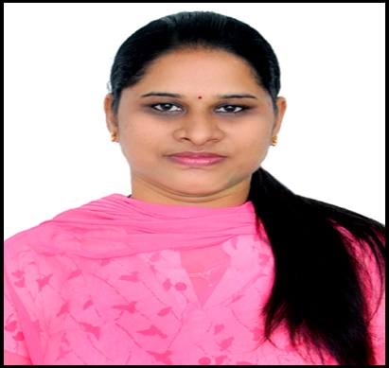 | Name: Dr.Shubhasri B.  Designation: Associate Professor  Qualification: BAMS, MD (Ayu)  Additional Qualification: Yoga Trainer(Ministry of AYUSH, Govt of India)  DOB : 22/02/1984  DOJ: 01/01/2019  Experience :5 years  Reg no: K.A.U.P Board 22449  Teacher code: AYSV00175
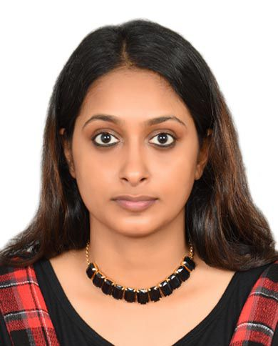 | Name: Dr.Sukanya V.P.  Designation: Assistant Professor  Qualification: BAMS, MD (Ayu)  AdditionalQualification: PGDBC  DOB : 31/03/1992  DOJ: 01/01/2021  Experience : 2 years  Reg no: K.A.U.P Board 43370  Teacher code: AYSV00699
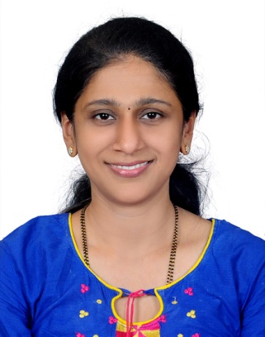 | Name: Dr. Roopa  Designation: Yoga Therapist  Qualification: M.Sc in Yoga Therapy  DOB: 01/09/1979  DOJ: 01/09/2022

